-------------------------------------------------------------------------------------------------------------------------------NAME: ARCHANA DEVI.P
REG NO: 192521192
COURSE: SOFTWARE TESTING
CODE: CSA0923
LAB PROGRAMS
Question 18: Check Whether a Number Is Even or Odd Using JUnit
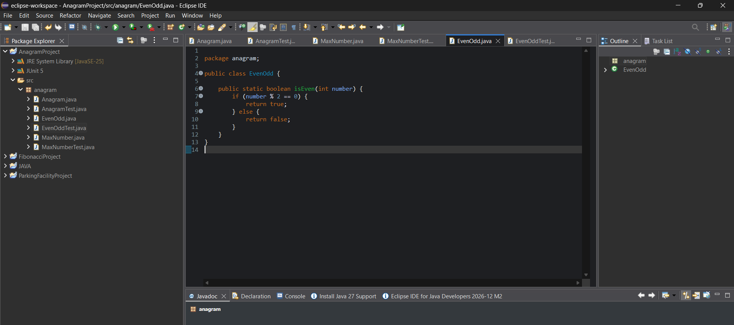

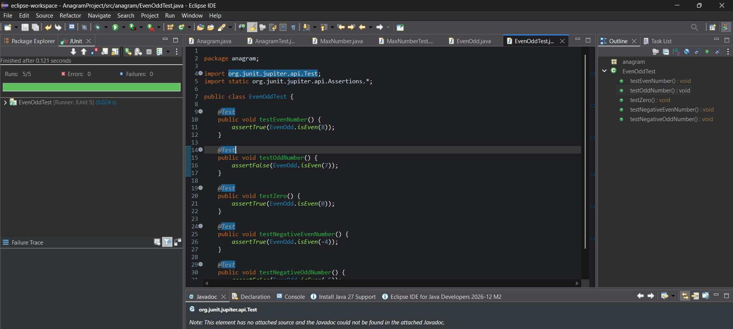

Result :
The even-or-odd program was implemented successfully and tested using JUnit 5. All five test cases passed, verifying both decision branches.

